Boost for the innovation process:
WIKA builds a new development centre

Klingenberg, December 2019.
WIKA keeps investing heavily in its future: At the headquarters in Klingenberg, the group of companies for industrial measurement technology is currently building a new development centre.

In the new complex, all departments involved in the innovation process for products and solutions will be concentrated. This includes laboratories and machinery. A flexible office structure supports the concept of short distances and effective communication.

The development centre consists of three interconnected wings on an uninterrupted ground floor, which also houses production areas. In front of it and also connected to it will be a further part of the building for reception, training facilities and administration. The completed new building should be ready to be occupied in the second half of 2020.

Number of characters: 794
Key words: Development centre

Manufacturer:
WIKA Alexander Wiegand SE & Co. KG
Alexander-Wiegand-Straße 30
63911 Klingenberg/Germany
Tel. +49 9372 132-5049
Fax +49 9372 132-406
vertrieb@wika.com
www.wika.de
WIKA company photograph:
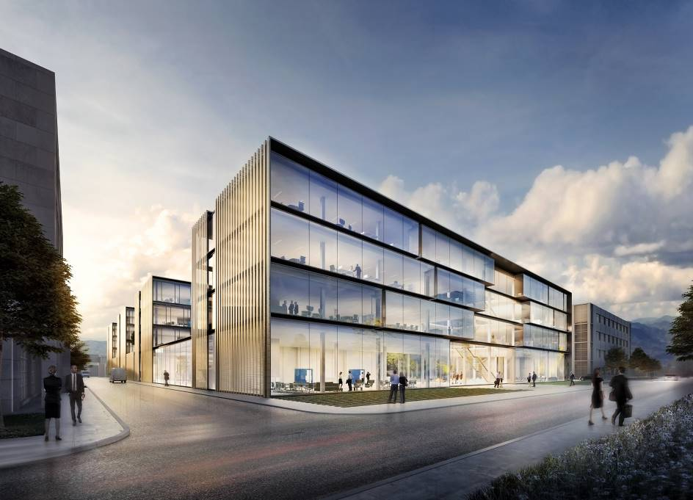

Edited by:
WIKA Alexander Wiegand SE & Co. KG
André Habel Nunes
Marketing Services
Alexander-Wiegand-Straße 30
63911 Klingenberg/Germany
Tel. +49 9372 132-8010
Fax +49 9372 132-8008010
andre.habel-nunes@wika.com
www.wika.de

WIKA press release

