New monoflange design
also prevents fugitive emissions
Klingenberg, May 2019
Compact design and minimised leakage potential: The new WIKA model IVM monoflange for connecting pressure measuring instruments to the process is particularly suitable for applications involving critical liquids, gases and vapours. Special seals also prevent fugitive emissions in accordance with TA-Luft (VDI 2440) and ISO 15848-1.

The monoflange is manufactured and tested to comply with various common standards such as ASME BPVC. It is designed for a long service life, even under difficult conditions. The valves work durably, smoothly and precisely, even at high pressures. The metal seat of the non-rotating spindle tip is tested for bubble tightness. To avoid seizure and leaks, the threaded mounting of the bonnets is not in contact with the medium.

In a version with OS&Y bonnet, firesafe tested to API 607 and ISO 10497/BS 6755-2, the IVM can also be mounted directly to the process without additional first isolation.

For the combination of the monoflange (or other protective devices) with a pressure measuring instrument, WIKA offers professional assembly. Customers receive an application-specific, complete solution (“hook-up”), ready for installation and leak-tested.

Number of characters: 1183
Key word: Monoflange IVM

Manufacturer:
WIKA Alexander Wiegand SE & Co. KG
Alexander-Wiegand-Straße 30
63911 Klingenberg/Germany
Tel. +49 9372 132-5049
Fax +49 9372 132-406
vertrieb@wika.com
www.wika.de

WIKA company photograph:
New monoflange design also prevents fugitive emissions

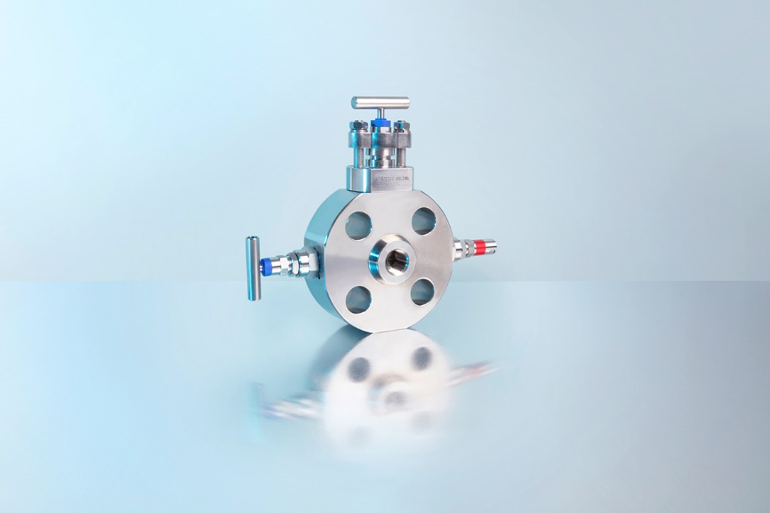

Edited by:
WIKA Alexander Wiegand SE & Co. KG
André Habel Nunes
Marketing Services
Alexander-Wiegand-Straße 30
63911 Klingenberg/Germany
Tel. +49 9372 132-8010
Fax +49 9372 132-8008010
andre.habel-nunes@wika.com
www.wika.de

WIKA press release 06/2019

