New high-pressure gauges qualified
as the first in accordance with DIN 16001

Klingenberg, October 2017.
WIKA has launched a new generation of high-pressure gauges. These are the first instruments of their kind which have been constructed and qualified in accordance with the new DIN 16001 high-pressure standard.

The marking in accordance with DIN 16001 certifies to the operator that no hazard will arise from these measuring instruments, even in critical situations. They fulfil standard-defined criteria of the category “S3” (safety pressure gauges with solid baffle wall).

With the new pressure gauges, the operator has a solution matched to each high-pressure application. The model PG23HP-P features scale ranges of up to 6,000 bar and a high indication accuracy of up to class 0.6 %. Its load cycle stability lies clearly over the requirements of the standard and is even maintained with dynamic pressure profiles. The PG23HP-S version has been designed for lower measuring and accuracy requirements.

Number of characters: 901
Key word: PG23HP-P/-S

Manufacturer:
WIKA Alexander Wiegand SE & Co. KG
Alexander-Wiegand-Straße 30
63911 Klingenberg/Germany
Tel. +49 9372 132-0
Fax +49 9372 132-406
vertrieb@wika.com
www.wika.de
WIKA company photograph:
High-pressure gauges PG23HP-P and PG23HP-S

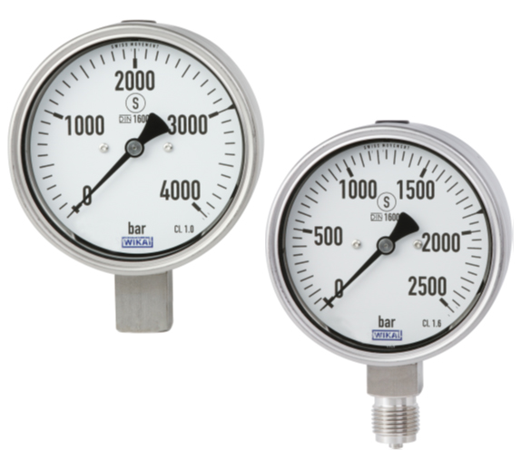

Edited by:
WIKA Alexander Wiegand SE & Co. KG
André Habel Nunes
Marketing Services
Alexander-Wiegand-Straße 30
63911 Klingenberg/Germany
Tel. +49 9372 132-8010
Fax +49 9372 132-8008010
andre.habel-nunes@wika.com
www.wika.de

WIKA press release 14/2017

